21st April 2016

**YOKOHAMA at Reifenmesse Essen 2016**

YOKOHAMA, the Japanese Tyre manufacturer will showcase its wide range of products in “REIFEN 2016”, to be held in Essen, Germany from the 24th-27th May. “REIFEN 2016” is one of the largest and most popular tyre trade fairs well known as “Reifenmesse”. Held every two years the event has traditionally counted with the significant participation of YOKOHAMA and will be displaying its latest products from a purposely designed booth, number 3A18 located in Hall 3.

Within the ADVAN area, YOKOHAMA’s premium High Performance tyre brand will be shown and will include the new ADVAN FLEVA V701 which is to set the all new standard of High Performance as a sporty tyre, and features which include extreme wet grip, emotional handling, low noise with a cool and attractive design. The ADVAN FLEVA V701 tyre reinforces the company’s premium product line "ADVAN", with a new concept focused on increasing drivers' control of the car. The new high-performance sport tyre brings greater driving pleasure to a diverse group of car owners, from sport car lovers to tuning enthusiasts to drivers of limousines, compact cars and CUVs.

The second new product is the ADVAN A052. “It is the ultimate street sporty tyre, with the most extreme grip ever”. In addition to these two new ADVAN products the full line-up includes the ADVAN NEOVA AD08R together with the Motorsport tyres A005 and A006 for wet and dry.

YOKOHAMA’s proud and long relationship with the most premium tyre manufacturers in the world is also showcased in the Original Equipment corner with YOKOHAMA’s latest achievements in OE and includes the Flagship tyre ADVAN Sport V105.

Also launched this year and to be featured at “Reifenmesse”, is the GEOLANDAR A/T G015, which is a real All-Terrain, On-Off Road tyre for SUVs developed to support the active vehicle lifestyle of drivers by delivering superior performance on any road surface under any weather condition. The use of an optimised tread pattern and new compound increases the tyre’s wear performance and traction performance on wet and snow-covered roads, hence displaying the snow flake marking.

The partnership with the English Premiership Champions Chelsea FC is also a focal part of the booth which also displays the BluEarth-A AE-50 Chelsea FC Edition tyre.

Two Concept Tyres highlighting the latest innovation from the Japanese Tyre manufacturer will also be on display with the BluEarth Air – lightweight tyre and the aerodynamic Outside Fin tyre – a must see for visitors interested in innovation and a glimpse into the future of tyres.

Winter tyres such as iceGUARD and the W*drive will also be on display, and commercial tyres, including TBS tyres such as the BluEarth 110L displayed for the first time in Europe - also the first TBS product which has been included in the BluEarth lineup - and the 902W Winter drive. The full range of commercial tyres from YOKOHAMA is completed with a featured OTR tyre.

Senior representatives from Head Office in Europe and Japan will attend the fair together with YOKOHAMA European country representatives and staff who will be available to provide further details and explanations on the premium products and technology presented.

For this edition of the Reifenmesse YOKOHAMA is displaying the very elegant Mercedes-Benz C-Class (W205) which will be branded in YOKOHAMA colours and has been expertly tuned jointly by PIECHA, who took care of the bodykit and Performmaster GmbH who expertly handled the electronics.

For more details on all the above, please visit the YOKOHAMA booth number 3A18 in Hall 3.

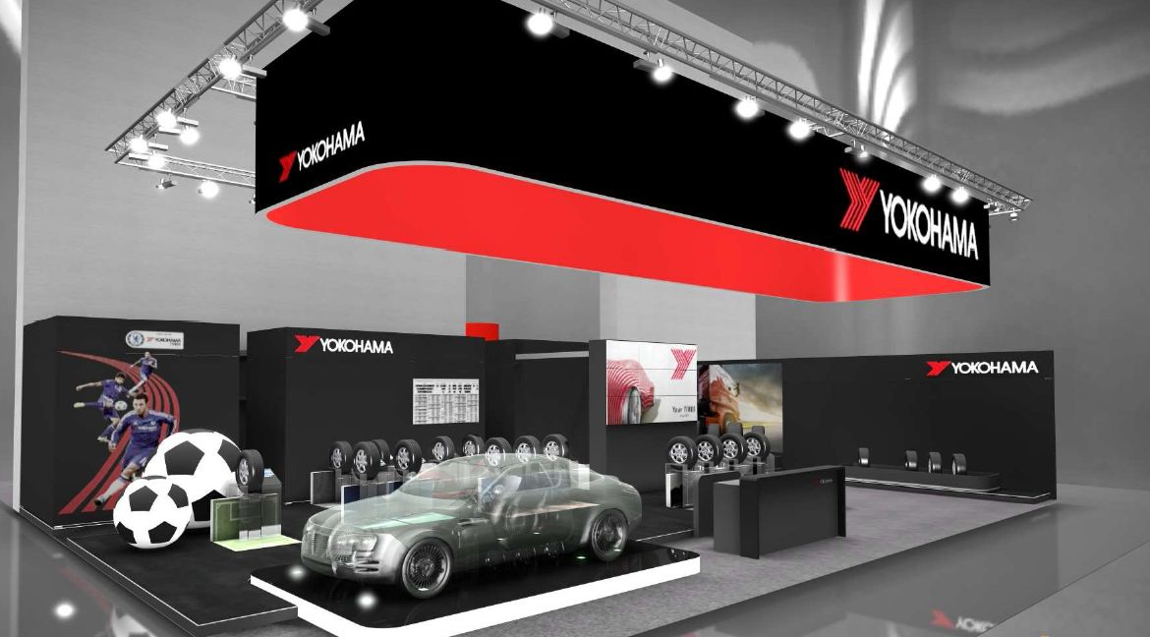

*YOKOHAMA booth at Reifenmesse*